Khan Academy
Student Setup

www.khanacademy.org
- Choose login in the top right corner.

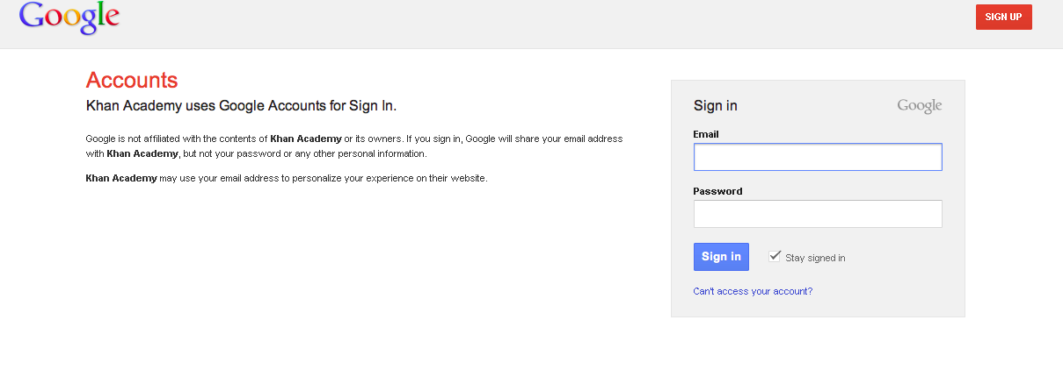
- Double click the Google box to login. You should see a site like this one. Students will enter their “fake” email and password that you should have been given. If you don’t have these, talk to your TITLE teacher.

- The first time students login, they will need to accept the policy. They will see this screen ONLY THE FIRST TIME. They will need to type the crazy letters into the box at the bottom and choose I accept.
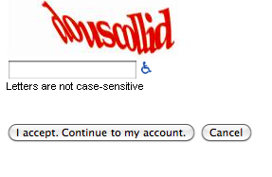
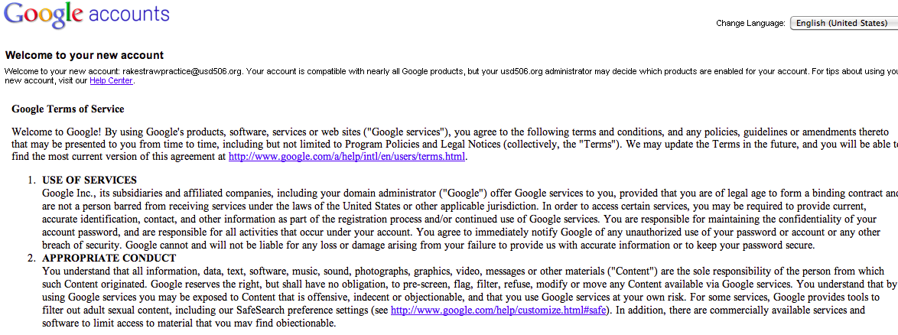

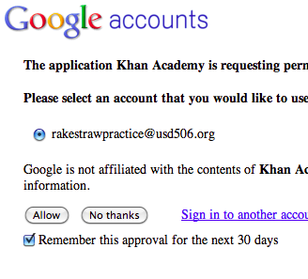
- They will then need to choose Allow.

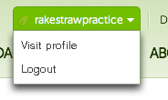
- This will bring up the Kahn Academy site. The next step is for students to set up their coaches. To do this, students need to choose Visit Profile under their name in the top right corner. If a pop-up box comes up, choose No Thanks, I know what I’m doing.
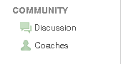
- On the left side, have students choose Coaches.

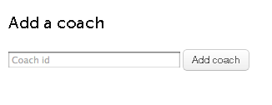
- Students then need to add you as a Coach. They will put your Kahn username into the box and Add Coach.

- Please also have students add Kim and/or Amber as a coach so we can assist as needed. To add Kim, have students enter: To add Amber, have students enter: coachwheeler@usd506.org. Students can have as many coaches as we want them to have.

- Students are now ready to do activities. Students should choose practice at the top and then they get a list of activities. As the teacher, you can decide where or how your students start. They can all start at different places or you can have all your students do the same module. This is up to you.

