Mentor Program Handbook

**Labette County**

Unified School District 506



The mission of the USD 506 mentor program is to provide support and guidance to new teachers and school specialists through a professional development program, which promotes excellence in education and increases retention of promising teachers and school specialists.

**ADDENDUM TO TEACHER MENTORING AND INDUCTION PLAN**

**Effective 7-1-2017**

Each item in this addendum is a change or addition to this plan’s contents. This addendum DOES NOT replace the contents of this plan. These items DO supersede any contradictory information found within the contents of this plan.

1. Teachers new to the profession and working under a license that is not professional level will participate for two full calendar years in this formal, KSDE-approved mentoring and induction program. (adds one year to minimum length of program)

2. Formal mentoring beyond the second year may be provided as determined by building and/or system administration. (changes “first year” to “second year”)

3. Each mentee will complete a needs assessment at the beginning of each year of formal mentoring, and the results of this needs assessment will drive the content of each individual participant’s mentoring experience. (adds annual needs assessment requirement)

4. This education system will establish a pool of mentors by the end of each school year. (new requirement)

5. Mentors will be trained prior to the start of the school year (changed from “by October 1”) or before being assigned a mentee if such assignment occurs after the start of the school year (clarifying language for midyear staffing).

6. Mentors and mentees will be paired by the date of the mentee’s first contract day. (adds this deadline)

7. Support for mentees will include “regular communication” with mentor and observations of other classrooms (removes specificity of communication frequency, which was previously “on a weekly basis”).

8. Mentor training and professional learning will address, but not necessarily be limited to, the following state required components (replaces previous list of 9 items):

i. Learning to observe, coach, and give constructive feedback to peers, including strategies for self-reflection

ii. Utilizing best instructional practices, classroom management, and organization);

iii. Dealing with difficult or resistant people and conflict resolution;

iv. Enhancing communication skills and building relationships;

v. Clarifying mentor’s roles and responsibilities;

vi. Practicing time management; and

vii. Developing knowledge of school/system policies and procedures including student assessment, curriculum, guides and supplemental resources.

9. Accountability measures of program effectiveness will include, but not necessarily be limited to, retention data, evaluation of mentee progress on needs assessment, and feedback by the building principal (adds these three measures).

** Labette County USD 506**

**Program Purpose, Goals, and Standards**

**Purpose:**

The USD 506 mentorship program is to promote excellence in education and to increase the retention of beginning teachers and school specialists through a professional development program. This program provides guidance, direction and support for new teachers and school specialists. Success will be achieved through collaboration, modeling, coaching, encouragement, and participation in a continuous, professional learning community.

**Goals:**

The goals of the USD 506 mentorship program will

* Support and provide one-on-one assistance to beginning teachers and school specialists, as well as teachers and school specialists new to the district
* Improve student achievement by promoting the personal and professional well-being of teachers and school specialists
* Increase the retention of promising new teachers and school specialists
* Provide new and beginning teachers and school specialists with immediate, personal peer contact in order to build a supportive environment for discovery of the school culture, policies, practices, and procedures
* Establish and maintain personal and professional relationships

**Standards:**

Program designed according to the Kansas Model Mentor and Induction Program Guidelines for New Teachers and School Specialists developed in 2015.

The expectations and responsibilities addressed in this handbook are based upon the Interstate Teaching Assessment and Support Consortium Model Core Teaching Standards (InTASC).

This mentorship program will address topics and skills in these categories:

* The Learner and Learning
  + Plans instruction based on learning and developmental levels of all students
  + Recognizes and fosters individual differences to establish a positive classroom culture
  + Establishes a classroom environment conducive to learning
* Content Knowledge
  + Demonstrates a thorough knowledge of the content
  + Provides a variety of innovative applications of knowledge
* Instructional Practice
  + Uses methods and techniques that are effective in meeting student needs
  + Uses varied assessments to measure learning progress
  + Delivers comprehensive instruction for students
* Professional Responsibility
  + Engages in reflection and continuous growth
  + Participates in collaboration and leadership opportunities

**Program Organization**

All teachers and school specialists who are new to the district will participate in a two-day induction program prior to the first contact day of returning staff.

First year teachers and school specialists will participate in at least one complete school year of mentoring.

Teachers and school specialists employed with 1 or more years of experience *may* be assigned a mentor at the discretion of the building administrator.

Mentors will participate in mentor training prior to the start of school. Ongoing training will occur for the mentors throughout the year; at least two mentor-only training sessions (one per semester).

***Please note***: Additional terms of mentoring support may be requested or required based on licensing changes, endorsements, or at the discretion of building principal.

**Structured Contact Time** (New Teachers)

1. Two-day induction program prior to the first contract day of returning staff.
2. One additional meeting each nine weeks with mentor.
3. One additional meeting each semester with mentor and building administrator (possibly outside of the school day).
4. Scheduled weekly contact and assistance from mentor.
5. At least 3 classroom observations throughout the school year from the mentor.
6. Release time from classroom for observations of the mentor and/or other teachers (at least twice per semester).

*One day each semester will be set up and designated as a make-up day for those missing any of the trainings.

All four areas of the Kansas Professional Education Standards will be addressed with mentees through the formal structure of the program. Those four areas are learner and learning, content knowledge, instructional practice, and professional responsibility.

The four training days throughout the school year will also include sessions on lesson planning related to *Classroom Instruction That Works and The Art & Science of Teaching* by Robert Marzano, *Kagan Cooperative Learning* by Spencer Kagan and Miguel Kagan and *Tools for Teaching* by Fred Jones. Continued work in the four training days throughout the year will include work with the District Curriculum Maps and state standards, as well as KU Content Enhancement Series (where applicable).

**New Teacher Orientation (2 days) August**

**1st year teacher/school specialist objectives:**

guidelines for success, professionalism, classroom management, classroom rules/consequences/classroom guide, family contacts, room arrangement, behavior management principles, routines & procedures, & monitoring techniques for classroom management plans.

**2nd year teacher objectives:**

review/revise classroom management plan, content enhancement and assessment strategies, improved instructional strategies.

**Training Days Throughout the Year: Sept., Oct., Jan and April**

**Sept. training Objectives:**

**1st year -** Review classroom management and mentor observation data. Implement student engagement/disruptions – Opportunities to Respond strategies. State standards/curriculum maps and lesson planning.

**2nd year -** Review/discuss mentor observation data on classroom management. Review/discuss Unit Development as related to observations. Marzano Strategies – research into practice. Demonstrate ideas for content specific Marzano strategies. KU Content Enhancements

**Oct. training Objectives:**

**1st year –** Review/discuss mentor observations on classroom management and engagement. Questioning strategies to increase student engagement. Review quarterly data: SRI, SMI (as applicable) and apply to lesson planning. Parent/Teacher Conference preparations and questions.

**2nd year** – Review/discuss feedback on Marzano strategies; Unit Development. Review quarterly data: SRI, SMI (as applicable) and apply to lesson planning. Expand unit materials and development related to Marzano strategies, Unit Development (KU Enhancement), district PD and state standards.

**Jan. training Objectives:**

**1st year -** review observation feedback and strategies for engaging students. Review quarterly data: SRI, SMI (as applicable) and apply to lesson planning. Expand strategies for engagement using Kagan Cooperative Learning, & Fred Jones Input/Output teaching. State Assessment preparation and discussion.

**2nd year** – Review/discuss feedback from implementation of Marzano and Unit Development strategies/materials. Review quarterly data: SRI, SMI (as applicable) and apply to lesson planning. Discuss/develop Unit assessments & state assessments.

**April training Objectives:**

**1st year –** Review/discuss mentor observations from classrooms, & state assessment data. Review quarterly data: SRI, SMI (as applicable) and apply to lesson planning. Discuss ways to keep students involved at the end of the school year. Reflect on year and plan for summer work. Celebrate yearend accomplishments.

**2nd year** – Review/discuss mentor observations, & state assessment data. Review quarterly data: SRI, SMI (as applicable) and apply to lesson planning. Review ways to keep students involved at the end of the school year. Reflect on year and plan for summer work. Celebrate year end accomplishments.

**Participant Responsibilities**

**The district will use a shared document “New Teacher Observation Form” to complete the required documentation of the mentor’s observation of the mentee.**

**The district will use Jim Knight’s Instructional Coaching Model to help mentors document and discuss the mentor’s observation. Mentors will facilitate the Principles of Partnership and immediately follow up the observation with collaboration time to explore the data collected during the observation. Together, the mentee and the mentor will create an After-action Report where they answer the questions: What was supposed to happen? What happened? What accounts for the difference? What will I do differently next time? This collaboration will be documented on a district, shared document.**

**Reflective Dialogue:**

**The district will use the model from *Coaching Classroom Management* by Randy Sprick, Jim Knight, Wendy Reinke, Tricia McKale Skyles, & Lynn Barnes to facilitate verbal dialogue and feedback between teacher/school specialist mentor and mentee. Data from this dialogue will be taken on a shared district document as the mentor/mentee have ongoing collaboration time. Mentors will gain initial data from beginning of the year interviews with their mentees. They will also use the Principles of Partnership throughout the year as they work with their mentees: equality, choice, voice, reflection, dialogue, and praxis. The district will provide training and templates/forms for the mentor’s use when working with the mentee. These forms will assist the mentor and guide their work. The forms will include, but not be limited to the following: observation, goal setting, pre-modeling conference and planning, intervention plan, monitoring, STOIC intervention planning, & teacher self- evaluation.**

**Mentor process framework for any concept/strategy:**

**Pre-conference with teacher, collect and summarize data, collaboratively explore data and identify needs, plan for implementation, pre-model conference and plan with teacher, mentor model the strategy, observe new teacher implementation, collaboration/follow-up. Continue cycle as needed.**

**Mentor Responsibilities:**

* Model professional growth and support mentee’s professional development (InTASC Standard 9)
* Foster an individualized program to assess and meet the needs of the new teacher or school specialist (InTASC Standard 2, 7)
* Help new teacher or school specialist during teacher workdays, if they so desire (InTASC Standard 10)
* Plan and conference with new teacher or school specialists weekly providing instructional support (InTASC Standard 10)
* Document all contact with mentee using district mentor time sheet (InTASC Standard 10)
* Support and assist mentee with various activities related to teaching:
  + Planning, preparing for and carrying out Back to School Night/Open House (InTASC Standard 10)
  + Parent-teacher conferences (InTASC Standard 10)
  + Familiarize mentee with school community and district culture (InTASC Standard 10)
  + Attendance and grade cards using PowerSchool (InTASC Standard 10)
  + Participating in district and state assessments (InTASC Standard 6)
  + Aligning instruction to state standards (InTASC Standard 7)
  + Supporting and modeling the district professional development (InTASC Standard 9)
  + Other professional responsibilities, as needed
* Observe mentee’s classroom at least three times each year during instruction to offer instructional assistance and feedback (2 visits during the first semester) (InTASC Standards 1-8)
* Facilitate classroom observations by mentee of another classroom (at least twice per semester) (InTASC Standard 10)
* Open your classroom to mentee and allow them to observe during instruction at least twice per semester (or another teacher) (InTASC Standard 10)
* Meet each semester with building administrator and mentee (InTASC Standard 9)
* Keep up-to-date mentor/mentee time sheet logs (InTASC Standard 10)
* Provide mentee with your confidence: Conversations between mentor and mentee should develop under a shelter of trust. Remember, you will be the one they turn to when they need assistance. (InTASC Standard 9)

*In the event that the mentor is unable to meet most of the needs of the mentee, the mentor should visit with the Mentor Director & building principal about possible reassignment.

*One day each semester will be set up and designated at a make-up day for those missing any of the trainings.

**At no time should the mentor be in a role of evaluating the new teacher or school specialist. Mentors will observe and offer suggestions to the mentee, but will not be involved in formative and summative evaluations.

**Mentee Responsibilities:**

* Attend district orientation and initial meetings (InTASC Standard 10)
* Conference with mentor once weekly (conferences are not optional and are a requirement of the district) (InTASC Standard 10)
* Attend district mentor program meetings (4 throughout the school year) (InTASC Standard 9)
* Meet each semester with your mentor and building administrator (InTASC Standard 9)
* Attend required district and building training sessions (InTASC Standard 10)
* Complete mentor program evaluation and provide feedback (InTASC Standard 10)
* Required minimum of three classroom visits throughout the year by mentor while mentee is teaching (2 visits during the first semester) (InTASC Standards 1-8)
* Required minimum of four classroom observation visits throughout the year by mentee to mentor’s classroom, or other teachers’ classrooms during instruction (twice per semester) (InTASC Standards 1-8)
* Ask questions, offer lesson plans for review, and strive to become familiar with your building and staff (InTASC Standards 7, 9, 10)

*School specialist mentor must be in the mentee’s area of specialty. This means mentor may be from another school.

**Building Principal Responsibilities:**

* Work with Mentor Director to recruit, select, match, and reassign (as needed) mentor teachers and school specialists with new teachers and school specialists within the school or outside the district, as necessary (ISLLC Standards 2-4)
* Support the mentorship program (ISLLC Standards 2-4)
* Assist in scheduling and coverage of classes to allow for mentor/mentee observations (ISLLC Standards 2-4)
* Provide program feedback to participants and to the mentor program director (ISLLC Standards 4)
* Meet with the mentor/mentee once each semester to discuss progress (ISLLC Standards 2-4)
* Aid in problem solving for concerns with mentor and/or mentee (ISLLC Standard 5)
* Honor confidentiality between mentor and mentee (ISLLC Standard 5)

**Selection and Matching Process**

**To be considered for mentoring, individual must do ONE of the following:**

* Begin training by October 1
* Have previously been trained
* Have a master’s degree in building-level leadership from an accredited program
* Be actively pursuing a master’s degree in building-level leadership from an accredited program
* Be in the school specialist’s area of specialty
* School specialist mentors MUST have current professional-level school specialist license and 3 years teaching experience.

**Selection Criteria for Mentor Teacher:**

* Principal recommendation
* At least three consecutive years employment in the Labette County School District or in another school district (as necessary for school specialist)
* Hold a professional license in the specialty are being mentored (may be someone from another building or district)
* Highly competent in instruction and classroom management
* Desires to be a mentor
* Sufficient availability for the new teacher or specialist, especially at the beginning of the year

**Training**

**Initial and Ongoing Training Requirements for Mentors:**

* Address mentor’s role
* Develop strategies for building relationships with new teachers and school specialists
* Develop skills for
  + observation of new teachers/specialists
  + assessment of needs of new teachers/specialists
  + strategies to address the needs of new teachers/specialists
* Teach coaching language and practice
* Develop strategies for guiding new teachers and specialists to reflect upon their own teaching
* Teach skills for guiding new teachers and specialists in using various types of formative assessment tools for instruction and differentiation
* Guide mentee in collecting and analyzing various types of student data to show evidence of learning
* Guide new teachers and specialists in their use of content standards for planning instruction
* Teach skills in using the professional education standards as a measure of assessing teacher practice

**New Teacher/School Specialist Training:**

Areas to be covered in new staff induction include but are not limited to:

* District policies – including a copy of the USD 506 Employee Handbook
* School safety
* Access to buildings
* Staff communication
* Licensure/staff development process/evaluations – PDP Toolbox/Talent Ed
* District Technology
* Content and grade specific instructional models and assessments
* Staff absences/Aesop
* Student handbook
* Classroom management plan
* Content and grade specific instructional strategies and assessments
* Differentiated Instruction
* SIT/MTSS – Multi-Tiered System of Supports
* Resources (copier, paper, media)
* Building-level programs (SMI, SRI, Pathways to Reading, etc.)
* Professional responsibilities and expectations of staff
* Supervision duties
* Extra duties
* Schedules
* Characteristics of the community and students

**Incentives**

**Mentors**

* Stipend for full-time classroom teacher serving as mentor: $1000 first year, $500 second year
* Professional development points

**New Teachers/School Specialists**

* Professional growth and performance
* Support system
* Professional development points
* Fulfills licensure requirements to move from provisional/initial license to professional license

**Program Evaluation**

Data considered in program evaluation: program goal achievement, completeness, depth, timeline, administrative support for mentors and mentees, mentor support of the mentee, and program strength and weaknesses.

* **Mentorship program survey: Principal**
* **Mentorship program survey: Mentor**
* **Mentorship program survey: Mentee**
* **Mentored teacher/school specialist retention rate**

Surveys and data will be evaluated by the mentorship committee to determine successfulness and/or necessary changes to the program.

*Mentoring Program Committee will be comprised of: superintendent, Title I coordinator, at least one building principal and mentor program director. Evaluation results will be reported to the district leadership team in June of each school year. Any necessary changes will be implemented the following school year.

The district will collect the data from the surveys through Google Forms. A separate survey will be given to the principal, mentor and mentee. Data used to answer the questions on the surveys will be gathered through anecdotal notes on shared district documents, and observation data collected during the school year.

**USD 506 New Teacher/Mentor**

Meeting Log

Date:________________ Time/Construct:__________________________

Teacher:________________________________________________________________

Purpose/Strategy:_________________________________________________________

Teacher Plan/To Do: Date Completed

* ______________________________________________ ________
* ______________________________________________ ________
* ______________________________________________ ________
* ______________________________________________ ________
* ______________________________________________ ________

Mentoring Plan/To Do Date Completed

* ______________________________________________ ________
* ______________________________________________ ________
* ______________________________________________ ________
* ______________________________________________ ________
* ______________________________________________ ________

Follow-up on:________________@____:____(Construct_____)

# USD 506 New Teacher Observation Form

Teacher:_______________________ School_________________________

Unit/Content:______________________ Construct:______________________

Date:_____________________________

|  |  |
| --- | --- |
| Teaching Practice | Comments |
|  |  |
|  |  |
|  |  |
|  |  |
|  |  |
|  |  |
|  |  |
|  |  |
|  |  |
|  |  |

** Labette County USD 506**

**New Teacher/School Specialist Needs Assessment**

1. Describe your previous classroom or teaching experiences (when, where, how long, etc.) Be sure to include your student teaching and other intern experiences.

2. What life experiences, hobbies, or personal interests do you bring to the classroom?

3. Describe an instance where you have experienced success in the classroom.

4. Describe an instance when things didn’t go as planned in the classroom.

5. What do you feel are your teaching strengths?

6. What part of this new job are you the most excited about?

** Labette County USD 506**

**Letter of Understanding**

The mentor and mentee agree…

1. Time commitment

We will meet regularly each week

Time/Duration: _________________________

Day: _________________________

2. Professional Development

We will observe each other teaching and conference afterwards.

We will participate in required building and district training sessions and support each other’s professional growth.

3. Confidentiality Pledge-

We agree that information about our professional or private lives shared in the course of our mentoring partnership shall not be disclosed to any other person, unless required by federal, state, or local laws and regulations. Examples of the types of information that must be disclosed are reports of abuse, threats of suicide, or admission of actions that could be prosecuted as felonies.

We further agree that the only documents and/or written records resulting from this mentoring process to be kept in the program’s archives:

* Mentor program conference/observation logs
* Anonymous program evaluations

4. Additional pledges:

I will be a good listener.

I will accept constructive feedback.

I will be reflective

I will be flexible and open.

I will commit to this mentoring relationship.

Mentor Signature Date

Mentee Signature

Date

** Labette County USD 506**

**New Teacher/School Specialist Evaluation of Mentoring Program**

Name: ______________________________________ Date: _______________

Mark the statement with the number that corresponds with your feelings about the USD 506 Mentoring Program.

1 Strongly disagree

2 Disagree

3 Agree

4 Strongly agree

1 2 3 4 My mentor provided first-year support by being caring and listening.

1 2 3 4 I had contact with my mentor at least once a week.

1 2 3 4 My mentor oriented me to the school and the school’s policies

and procedures.

1 2 3 4 My mentor was available when I needed his or her help.

1 2 3 4 My mentor suggested resources (both people and materials) that

helped my in my first year of teaching.

1 2 3 4 The mentor program helped me be a better teacher/specialist.

1 2 3 4 My observation of other teachers/specialists was valuable.

What suggestions do you have to improve the mentorship program at USD 506?

________________________________________________________________________________________________________________________________________________________________________________________________________________________________________________________________________________________

What questions/concerns do you have about the mentorship program at USD 506?

________________________________________________________________________________________________________________________________________________________________________________________________________________________________________________________________________________________

** Labette County USD 506**

**Mentor Teacher/School Specialist Evaluation of Mentoring Program**

Name: ______________________________________ Date: _______________

Mark the statement with the number that corresponds with your feelings about the USD 506 Mentoring Program.

1 Strongly disagree

2 Disagree

3 Agree

4 Strongly agree

1 2 3 4 I was adequately prepared to be a new teacher mentor.

1 2 3 4 I had contact with my mentee at least once a week.

1 2 3 4 I observed my mentee teaching a lesson, which included a follow-

up conference.

1 2 3 4 My mentee observed me teaching a lesson, which included a

follow-up conference.

1 2 3 4 I familiarized the new teacher to the school and the schools’

policies and procedures.

1 2 3 4 My mentee accepted suggestions and help as offered.

1 2 3 4 I provided suggestions to find resources (people and materials) to

my mentee.

What suggestions do you have to improve the mentorship program at USD 506?

__________________________________________________________________________________________________________________________________________________________________________________________________________________________________________________________________________________________________________________________________________________________________________________________________________________________________________________________________________________________________________** Labette County USD 506**

**Building Principal Evaluation of Mentoring Program**

Name of Mentor: ______________________________________

Name of Mentee: ______________________________________

Mark the statement with the number that corresponds with your feelings about the USD 506 Mentoring Program.

1 Strongly disagree

2 Disagree

3 Agree

4 Strongly agree

1 2 3 4 The mentor was adequately prepared to be a mentor.

1 2 3 4 The mentor had contact with the mentee at least once a week.

1 2 3 4 The building mentor and I oriented the mentee to the school

and its policies and procedures.

1 2 3 4 The mentor was available to the mentee when he or she

needed help.

1 2 3 4 The mentor suggested resources (both people and materials) that

helped with the mentee’s first year.

1 2 3 4 The mentee put forth adequate effort to acclimate and improve

professionally.

1 2 3 4 The mentee was willing to seek and accept assistance.

1 2 3 4 The district support was adequate for the mentorship program.

What suggestions do you have to improve the mentorship program at USD 506?

____________________________________________________________________________________________________________________________________________________________________________________________________________________________________________________________________________________________________________________________________________________________________________________________________________________________________

Principal signature Date

** Labette County USD 506**

**Anticipated Monthly Meeting Topics:**

**The district will use a shared document “Teacher/Mentor Meeting Time Sheet Log” to complete the required documentation of weekly communications between teacher/school specialist mentor and mentee.**

**Before the Start of School**

* Discuss confidentiality
* Teacher work area-desk, computer, email, etc
* Room set-up, student desks
* Planning for the first day and first week of school
* Discipline and office referrals
* Plan book, how to plan, sub-plans, organization, pacing, curriculum map
* Learn about copier, printers, projectors, and other resources and equipment
* State and district standards—ksde.org
* Locations of texts, instructional materials, and other supplies
* Ordering supplies – requisitions
* District technology (Aesop, PowerSchool, E-mail, TalentEd, GAFE)
* Classroom management techniques
* Building tour – work area, mailbox, parking, restrooms, etc
* Class sponsorship (LCHS and if applicable at elementary buildings)
* School procedures – Mission statement, Code of Conduct, Employee Handbook
* Support systems – SIT process and procedures
* District calendar - priority of events
* Communications – use of email, Bright Arrow, phone, etc
* Curriculum resources – library, TV, LCD, SMART Board, projectors, elmos, etc
* Supervision duties and building routines and procedures
* Community norms and expectations

**August and September**

* Appearance and professionalism
* Classroom management plan (time, discipline, schedule, classroom setup)
* Curriculum and curriculum mapping
* Testing: SRI, SMI, Pathways to Reading, State assessments
* Building policies and procedures (lesson plans, schedule work times, staff meetings)
* Chain of command/protocol
* Grades/grade book/progress reports
* Standards-based report cards (Primary)
* Using PowerSchool – attendance, lunch, etc.
* Back to School Night/Open House
* Staff development procedures and timelines (PDP Toolbox)
* Copies and office use
* Requesting Leave– Using Aesop, personal/professional leave, sub plans
* Emergency plans and procedures
* Parent-teacher Conferences
* Checking out and refueling school vehicles
* SIT process and procedure
* Field trips (Maintenance Direct)
* Schedule observation of mentee with conference

**October**

* Classroom management (how things are going)
* Special education
* Student cumulative folders
* Meetings – IEP, SIT
* Parent-teacher conferences
* Evaluations: formative, summative, walk-through
* Collaboration time – purpose and planning
* Overview of previous month – concerns or questions?
* Quarterly data: SRI, SMI (as applicable)

**November**

* Assessments: local and state (formatives)
* Classroom management (office referrals, behavior plans)
* Progress reports
* Reviewing curriculum map
* Staff personnel and their roles
* Working with parents – visits and volunteers
* Working with paraprofessionals – optimal utilization
* Encouraging or motivating low-achieving students
* Analyze data from local assessments
* Tardy and attendance policy
* Meeting student needs (AO and Grizzly Time, LCHS)
* Thanksgiving break
* Professional development – PDP Toolbox
* Concerns or questions
* Schedule observation of mentee with conference

**December**

* Meeting with mentor and building-level administrator
* End of semester duties
* Classroom management
* Emergency resources – Counselors
* Preparation for the spring semester
* Preparation and administration of finals, if applicable (LCHS)
* Submitting semester grades
* Quarterly data: SRI, SMI (as applicable)
* Christmas program, if applicable
* Christmas break

**January**

* Organization
* Classroom management
* Analyze data from formative state assessments, if applicable
* Progress reports
* Support and answer questions
* Student pre-enrollment procedures for following year (LCHS & 8th grade)
* Discussion of testing window for state assessments

**February**

* Preparing “ALL” students for state assessments
* Parent-teacher conferences
* Classroom management
* Review curriculum map
* Parent contact
* Teacher contract notification (renewal/non-renewal)
* Graduation issues (8th grades)
* Spring field trips

**March**

* Go over Kansas Assessment Program– appearance, logging on, etc.
* Analyze data for state and local assessments
* Support and answer questions
* Classroom management
* Quarterly data: SRI, SMI (as applicable)
* Schedule observation of mentee with conference

**April**

* Progress reports
* Discuss licensure with mentee – if first year, need to change provisional to professional licensure using Mentorship documentation. (ksde.org)
* Classroom management
* Surviving until May
* Reviewing curriculum map – changes needed?
* Fees (lost books, etc.)

**May**

* Meeting with mentor and building-level administrator
* End of year preparation
* Classroom management
* Quarterly data: SRI, SMI (as applicable)
* Textbook and classroom inventory
* Plan – equipment and supplies for next year
* Summer payroll options
* Finals schedule (LCHS)
* Report card
* Field day (elementary buildings)
* Teacher check-out procedures (keys, books, grades, etc.)

**Summer Months**

If you will mentor a second year, stay in touch. Keep building rapport.

Macintosh HD:Users:admin:Desktop:Kansas Model Mentor and Induction Program Guidelines.pdf

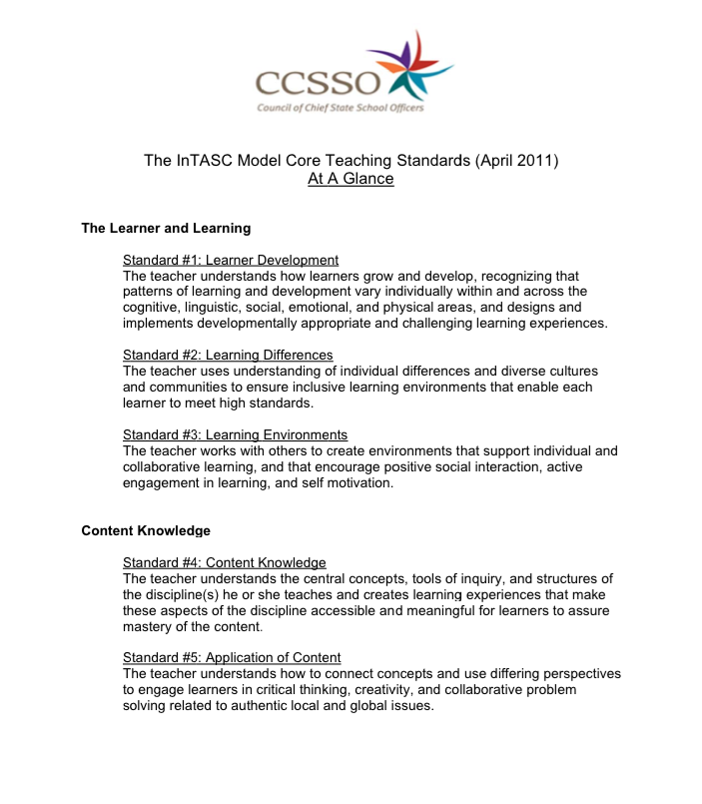

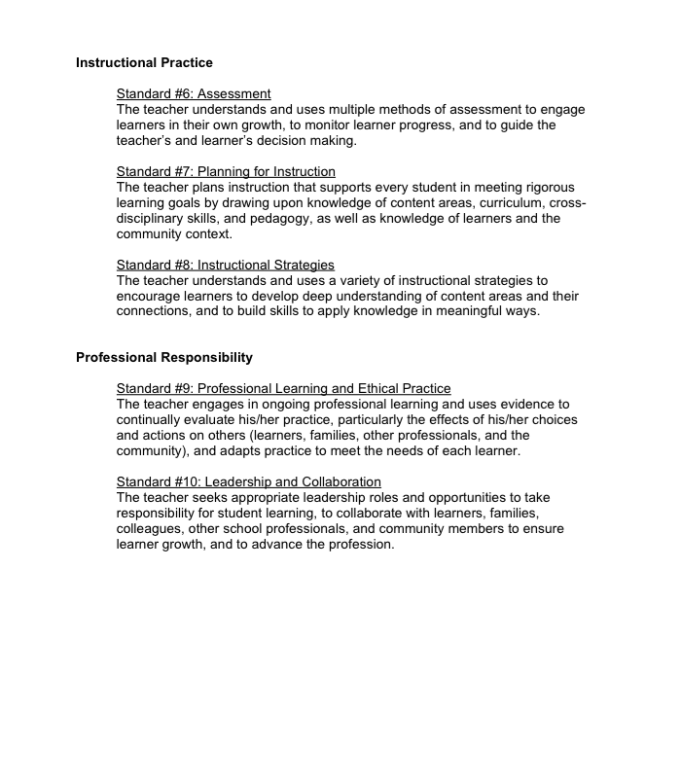

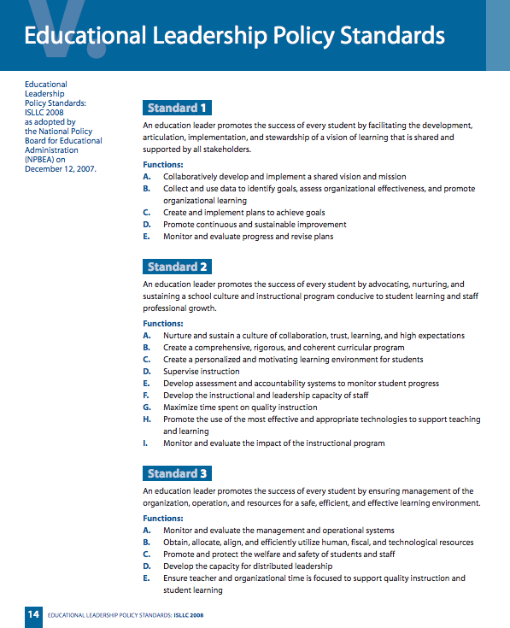

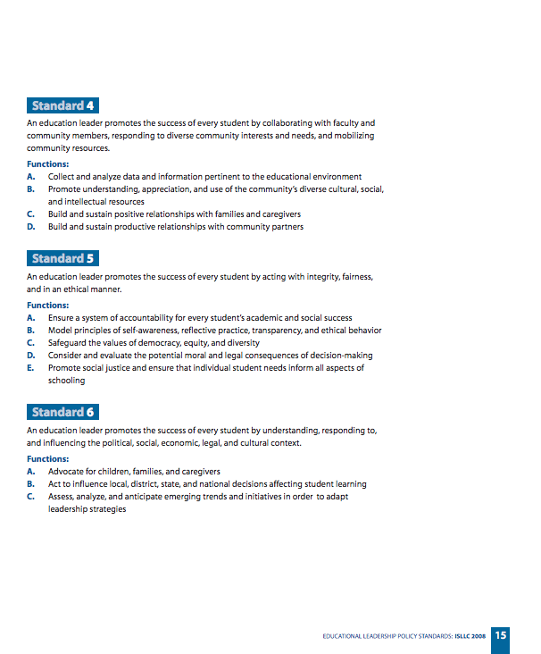

Works Cited

Council of Chief State School Officers. Educational Leadership Policy Standards: 2008. Digital image. Www.ccsso.org. 1 Jan. 2008. Web.

Jones, Fredric H., and Patrick Jones. *Fred Jones Tools for Teaching: Discipline, Instruction, Motivation*. Fredric H. Jones & Associates, 2007. Print.

Kagan, Spencer, and Miguel Kagan. *Kagan Cooperative Learning.* Kagan Cooperative Learning, 2009. Print.

"Kansas Model Mentor and Induction Program Guidelines for New Teachers and School Specialists." Kansas State Department of Education. KSDE, 9 Feb. 2015. Web. 9 Apr. 2015. <http://www.ksde.org/Portals/0/TLA/Mentoring/Kansas Model Mentor and Induction Program Guidelines.pdf>.

Marzano, Robert J., Debra Pickering, and Jane E. Pollock. *Classroom Instruction That Works: Research-based Strategies for Increasing Student Achievement*. Alexandria, VA: Association for Supervision and Curriculum Development, 2001. Print.

Marzano, Robert J. *The Art & Science of Teaching: A Comprehensive Framework for Effective Instruction (Professional Development).* Alexandria, VA: Association for Supervision and Curriculum Development, 2007. Print.

Sprick, Randy. *CHAMPS: A Proactive and Positive Approach to Classroom Management, 2nd Edition.* Pacific Northwest Publishing; 2nd Edition, 2009. Print.

Sprick, Randy, and Wendy M. Reinke. *Coaching Classroom Management: Strategies and Tools for Administrators and Coaches*. Pacific Northwest Publishing; 2nd Edition, 2010. Print.

"The InTASC Model Core Teaching Standards." Council of Chief State School Officers. CCSSO, 1 Apr. 2011. Web. 9 Apr. 2015. <http://www.ccsso.org/Documents/2011/InTASC 2011 Standards At A Glance.pdf>.